

**Introduction**

 .

Community-acquired pneumonia (CAP) remains the leading cause of infectious disease death in developed countries.  Described by Sir William Osler as “captain of the men of death,” it dates back to antiquity.  However, we are only beginning to understand the best ways to treat it.

 .

**Part 1:  The Pneumococcal meningitis story**

.

Ceftriaxone causes bacteriolysis of pneumococcus, releasing inflammatory cell wall products that exacerbate meningeal inflammation.  In rabbits, steroid pre-treatment blocks this surge in inflammation ([Lutsar 2003](http://www.ncbi.nlm.nih.gov/pubmed/12951330)).  Clinically, dexamethasone pre-treatment of bacterial meningitis reduces neurologic complications, an effect which seems to be driven largely by the subset of patients with pneumococcal meningitis ([De Gans 2002](http://www.ncbi.nlm.nih.gov/pubmed/12432041)).

.

Thus, the interactions of pneumococcus, ceftriaxone, and steroid have been established in rabbit and human meningeal infection.  There is no reason to expect that these interactions would be different in pneumonia.

.

**Part 2:  Understanding the effect of different antibiotics on inflammation**

.

The most commonly used antibiotics for CAP are azithromycin, beta-lactams, and respiratory fluoroquinolones (levofloxacin and moxifloxacin).  These drugs have different effects on inflammation:

.

**Beta-lactams**:  These don’t seem to affect the immune system directly.  Beta-lactams will, however, cause bacterial cell lysis with the release of bacterial proteins (e.g., pneumolysin), triggering inflammation.

.

**Azithromycin**:  The ability of azithromycin to suppress inflammation is widely appreciated ([Parnham 2014](http://www.ncbi.nlm.nih.gov/pubmed/24631273)).  Azithromycin also acts as a bacterial protein synthesis inhibitor, which may directly suppresses the production of bacterial products including pneumolysin ([Anderson 2007](http://www.ncbi.nlm.nih.gov/pubmed/17848373)).

.

**Fluoroquinolones**:  Although not widely appreciated, fluoroquinolones also suppress inflammation ([Dalhoff 2005](http://www.ncbi.nlm.nih.gov/pubmed/16518713)).  For example, in mouse models moxifloxacin reduces inflammation incited by *heat-killed*bacteria, proving anti-inflammatory activity aside from any anti-microbial activity ([Beisswenger 2014](http://www.ncbi.nlm.nih.gov/pubmed/25034539)).

.

**Part 3:  Best antibiotics for severe CAP?**

.

Little is known about antibiotic therapy for severe CAP, because nearly all studies have excluded severely ill patients.  Guidelines recommend against the use of fluoroquinolone monotherapy, on the basis of trends toward inferiority in a single RCT of severely ill patients ([Leroy 2005](http://www.ncbi.nlm.nih.gov/pubmed/16002932), [Mandell 2007](http://cid.oxfordjournals.org/content/44/Supplement_2/S27.full.pdf+html)).  Rising resistance to fluoroquinolones argues further against their use.

.

Combination therapy with a macrolide and beta-lactam (e.g. ceftriaxone plus azithromycin) is supported by the greatest volume of evidence and experience.  Dual therapy with azithromycin correlates in many studies with improved mortality compared to beta-lactam monotherapy.  This correlation persists even among patients with pneumococcus, suggesting that the benefit of azithromycin may reflect its immunomodulatory properties rather than simply providing atypical coverage ([Shorr 2013](http://www.ncbi.nlm.nih.gov/pubmed/23794577)).  Azithromycin *does not* cause torsade de pointes or sudden death; this myth was debunked [here](http://emcrit.org/torsade-de-pointes/myth-busting-azithromycin-does-not-cause-torsade-de-pointes-or-increase-mortality/).

.

An alternative combination which is also adherent with USA guidelines is a beta-lactam plus a fluoroquinolone.  A significant role of the fluoroquinolone in this situation might be to reduce lung inflammation, an effect demonstrated in mouse models ([Majhi 2014](http://www.ncbi.nlm.nih.gov/pubmed/24957840)).  However, fluoroquinolones have more side-effects than azithromycin (including delirium, tendon rupture, and higher rates of clostridium difficile).

.

Thus, the combination of a reasonably broad-spectrum beta-lactam (e.g. ceftriaxone or ampicillin-sulbactam) plus azithromycin currently seems to be the best choice.  Previously, many patients with penicillin allergy were treated with fluoroquinolones.  However, penicillin-allergic patients have a negligible rate of reaction to third or fourth generation cephalosporins, so fluoroquinolone substitution is unnecessary ([Campagna 2012](http://www.ncbi.nlm.nih.gov/pubmed/21742459)).

.

**Part 4:  Patients with risk factors for MRSA or Pseudomonas**

.

There isn't enough space to really cover this.  It is worth noting that most of these patients will *not* actually have MRSA or pseudomonas, so the basic principles of treating severe CAP still apply.  For example, a regimen of piperacillin-tazobactam (Zosyn) monotherapy or vancomycin plus piperacillin-tazobactam (“Vosyn”) is inadequate because it lacks atypical or immunomodulative therapy.  A macrolide plus beta-lactam combination *remains*a good choice for the backbone of the antibiotic regimen.  If more gram-negative coverage is desired, a broader beta-lactam might be selected (e.g. azithromycin plus cefepime).

.

[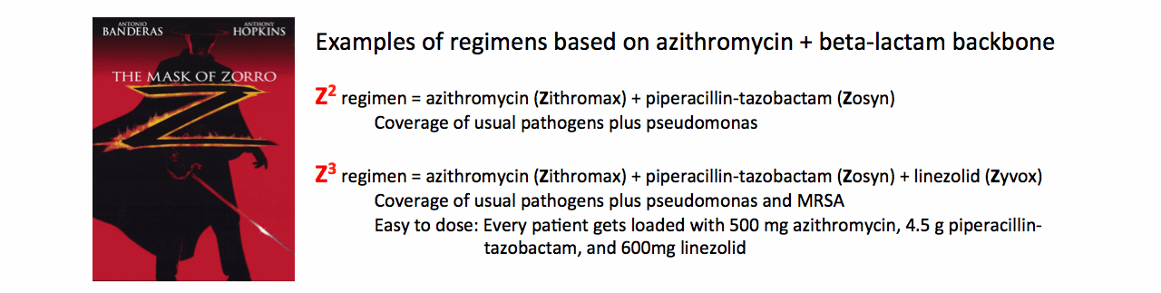](https://i1.wp.com/3.bp.blogspot.com/-SAASyZ-9H6Q/VdFAEvBHD5I/AAAAAAAABso/xtljOZfywqs/s1600/zorro.gif)

.

**Part 5:  Steroid therapy for CAP**

.

The concept of using steroid for pneumonia dates back to the 1950s, but more evidence has emerged over the last five years:

.

[Snijders et al. 2010](http://www.ncbi.nlm.nih.gov/pubmed/20133929)randomized 213 hospitalized patients to receive placebo vs. 40 mg prednisolone daily for a week.  There was no difference in the primary outcome (clinical improvement at seven days), length of stay, or time to clinical stability.  Clinical deterioration >72 hours after admission was more common in patients receiving steroid.  However, when analyzed on a *per protocol* basis using a Fisher Exact test, the difference in late clinical failure is not significant (1)(table below).  Although the increase in late failure was emphasized in their manuscript, this is a secondary outcome of questionable statistical significance.

.

[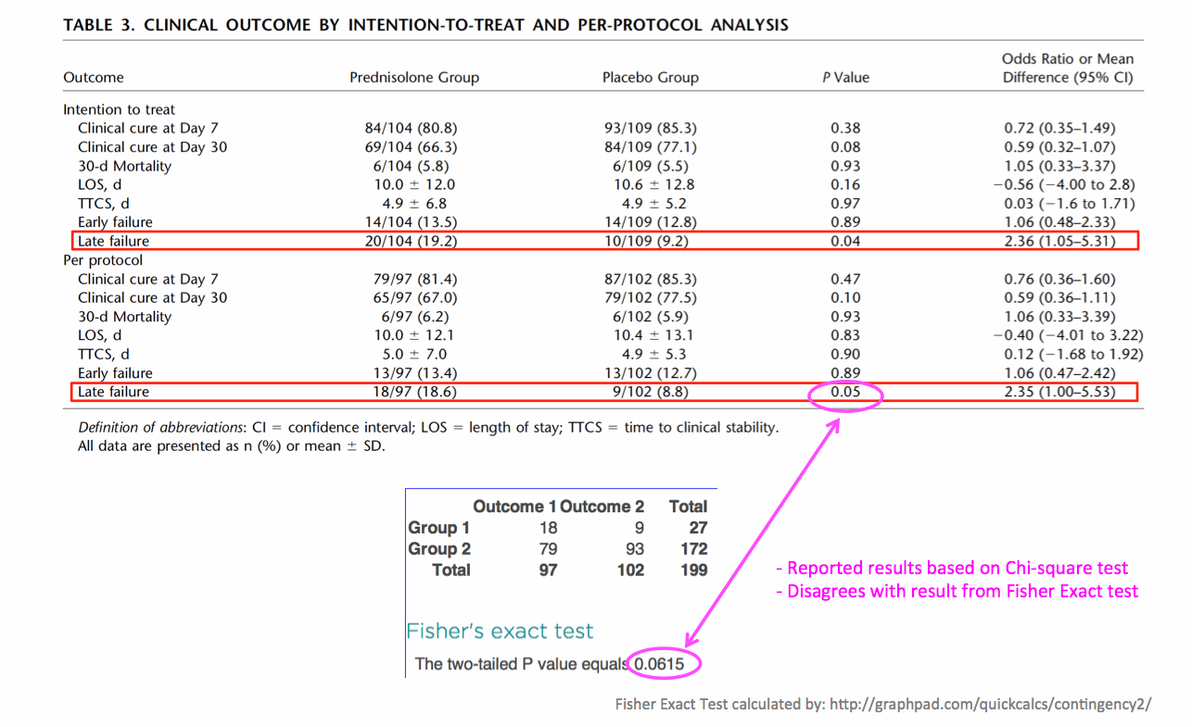](https://i1.wp.com/2.bp.blogspot.com/-QRDqx09cRUs/VdFALexzQ8I/AAAAAAAABsw/Np05ua4oWmk/s1600/snijders1.gif)

.

Two years later these authors performed a re-analysis of the data based on whether the patients were located in the ICU ([Snijders 2012](http://erj.ersjournals.com/content/40/Suppl_56/P1734.full.pdf)).  90% of patients were not admitted to the ICU, and among these patients there was faster stabilization with steroid:

.

[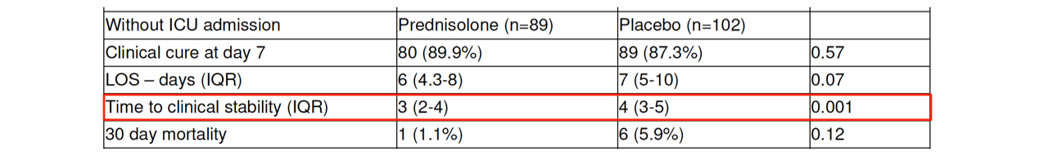](https://i0.wp.com/2.bp.blogspot.com/-wjB8qgbVEEg/VdFAVSvUtfI/AAAAAAAABs4/QLBjj_Yf-jw/s1600/snijders2.gif)

.

[Meijvis et al 2011](http://www.ncbi.nlm.nih.gov/pubmed/21636122)randomized 304 patients admitted to the medicine ward to receive placebo vs. dexamethasone 5 mg/day for four days.  The primary outcome was hospital length of stay, which was reduced in the dexamethasone group (6.5 days vs. 7.5 days, *p*=0.048; figure below).  There was an increase in hyperglycemia among patients receiving dexamethasone.

.

[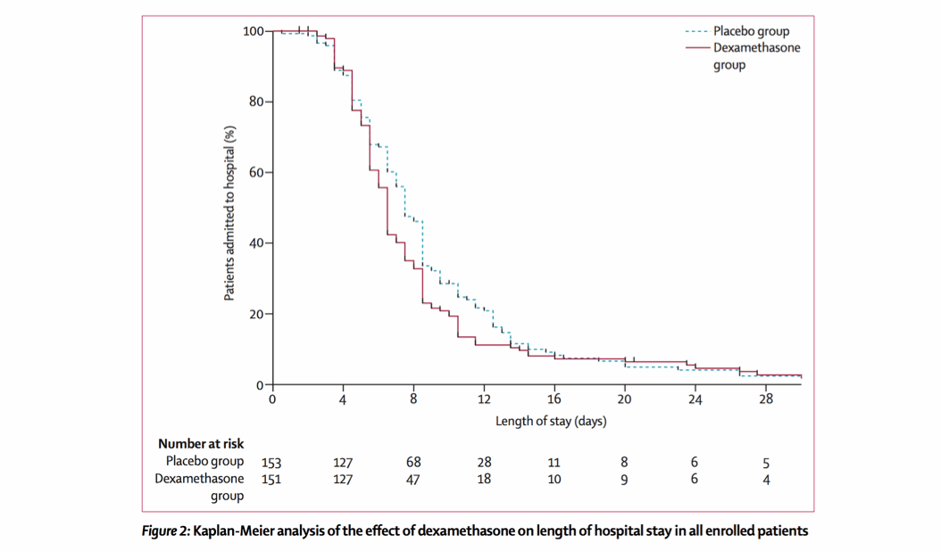](https://i0.wp.com/1.bp.blogspot.com/-07VEbkEFPsc/VdFAbwWNjnI/AAAAAAAABtA/2wi-_aIeGtw/s1600/meijvis.gif)

.

[Blum et al 2015](http://www.ncbi.nlm.nih.gov/pubmed/25608756)randomized 785 patients admitted to the hospital to placebo vs. prednisone 50 mg daily for seven days.  The primary outcome was time to clinical stability, which was improved in patients receiving steroid (3.0 vs. 4.4 days, *p*<0.0001; figure below).  Adjusted analysis accounting for a history of COPD did not affect this result.  This translated into a reduction in hospital length of stay by one day (*p*=0.012). Patients receiving steroid had a higher rate of hyperglycemia requiring insulin treatment (19% vs 11%, *p*=0.001), with similar rates of other complications.

.

[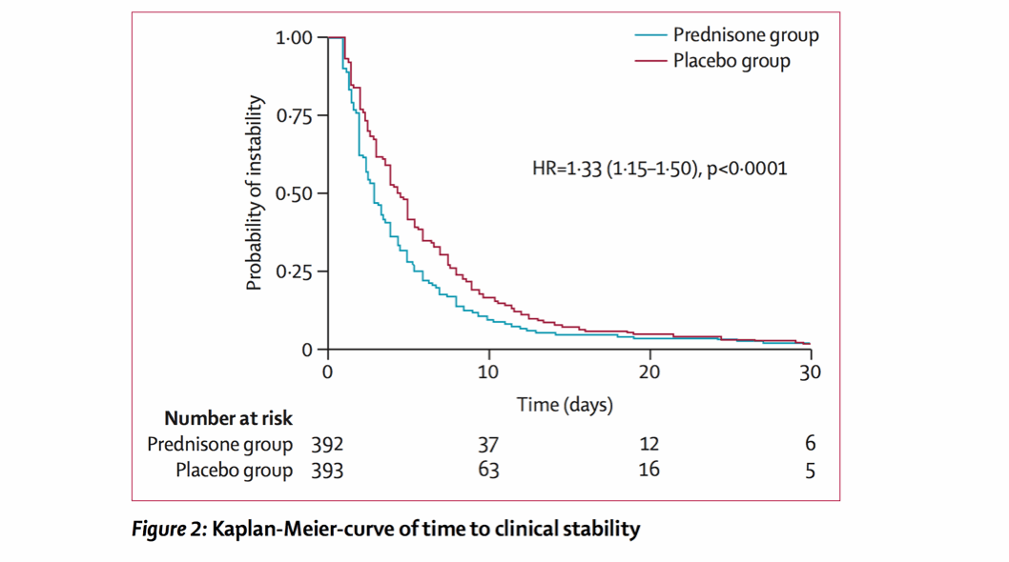](https://i1.wp.com/1.bp.blogspot.com/-lCnJvUFpCO4/VdFAh3-fPqI/AAAAAAAABtI/fwMc_ZvKLCg/s1600/blum.gif)

.

[Torres et al 2015](http://www.ncbi.nlm.nih.gov/pubmed/25688779)randomized 120 patients with severe pneumonia and C-reactive protein >150 mg/L to placebo vs. methylprednisolone 0.5 mg/kg Q12hr for five days.  The primary outcome was treatment failure, a composite including intubation, shock, death, and radiologic progression.  Steroid therapy caused a reduction in treatment failure, although this was largely driven by reductions in radiographic progression.

.

[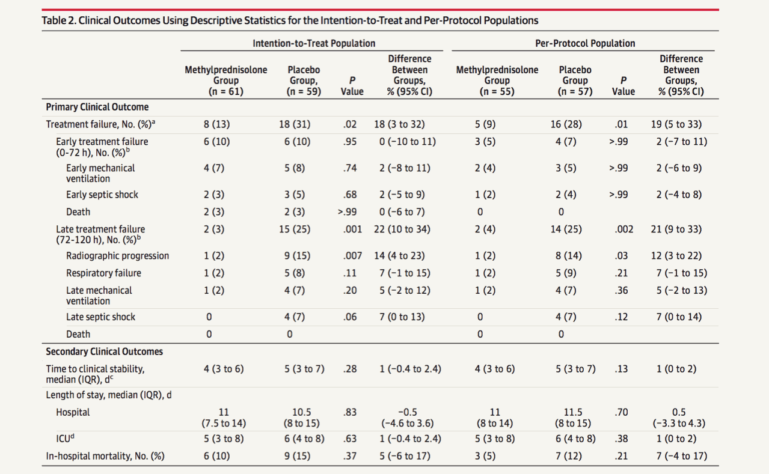](https://i0.wp.com/3.bp.blogspot.com/-rRCj2GLf2Rk/VdFAnnYBR9I/AAAAAAAABtQ/pPAGVXuC7nM/s1600/torres.gif)

.

[Siemieniuk 2015](http://www.ncbi.nlm.nih.gov/pubmed/26258555)**:**This is the most recent meta-analysis, with key results as shown below.

.

[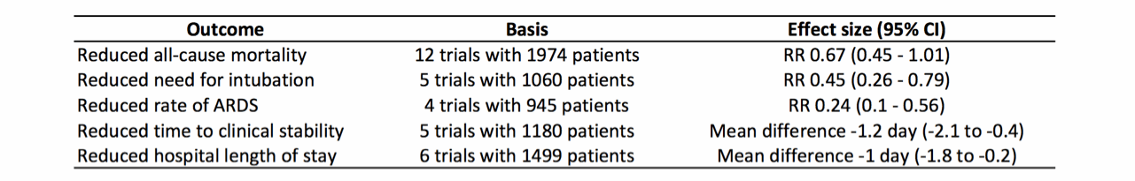](https://i1.wp.com/1.bp.blogspot.com/-J4YcliwOlg0/VdFAtUXW4wI/AAAAAAAABtY/iHzxsHrdONI/s1600/meta.gif)

.

This study failed to find evidence of significant harm (the only increased adverse event was hyperglycemia).  This is identical to safety data for steroid in septic shock (discussed previously [here](http://emcrit.org/steroid/steroids-in-septic-shock-four-misconceptions-and-one-truth/)).

.

**Synthesizing data on steroid**

.

Nearly all studies show benefit for steroid in pneumonia, with the exception of Snijders 2010.  This study reported that sicker patients treated with steroid experienced a trend towards delayed stabilization.  Alternatively, patients outside of the ICU treated with steroid improved more rapidly.  This dichotomy could reflect the unusual antibiotic scheme these authors used:  amoxicillin was used for mild-moderate pneumonia whereas moxifloxacin was used for moderate-severe pneumonia.  Overall, 39% of patients received fluoroquinolone (compared to, for example, 1% in Meijvis et al. and 13% in Blum et al.).  Since moxifloxacin has immunosuppressive properties, it is conceivable that steroid is unhelpful in combination with moxifloxacin.  This might explain why steroid was ineffective among sicker patients who were receiving moxifloxacin (2).

.

The two largest studies (Blum et al. with *n*=785 and Meijvis et al. with *n*=304) both found that steroid reduced the length of stay.  Meta-analysis confirmed this, while suggesting a variety of additional benefits (e.g., reduced need for intubation).  To put this into perspective, this evidence is more robust than data supporting steroid in COPD exacerbation (which is mostly based on an RCT that showed reduced length of stay by one day; [Niewoehner 1999](http://www.ncbi.nlm.nih.gov/pubmed/10379017)).  On a mg/kg basis, the doses of dexamethasone involved are similar to those used for *symptomatic*relief of pharyngitis in *kids* (0.6 mg/kg; [Olympia 2005](http://www.ncbi.nlm.nih.gov/pubmed/15753273)).  So we're seeing a respectable benefit from a moderate and safe dose of steroid.

.

However, steroid isn't for everyone.  Pending further investigation, the following caveats bear consideration:

 .

* Patients with contraindications to steroid were excluded from RCTs.
* Steroid might not be beneficial when combined with fluoroquinolone.  This combination has not been investigated adequately, with a signal of possible harm within Snijders 2010.
* CAP is a collection of different diseases.  Retrospective observational studies have found that steroid use correlates with increased mortality in influenza ([Yang 2015](http://www.ncbi.nlm.nih.gov/pubmed/26123860)).  For patients presenting during flu season with a clinical syndrome of influenza pneumonia (especially suggested by a *diffuse* infiltrates on chest radiograph and lack of significant consolidation on ultrasound) it may be sensible to avoid steroid.  Radiologic and ultrasonographic patterns of CAP were explored [last week](http://emcrit.org/bronchopneumonia/proposal-most-community-acquired-pneumonias-with-extensive-ultrasonographic-consolidation-are-pneumococcus/).

.

[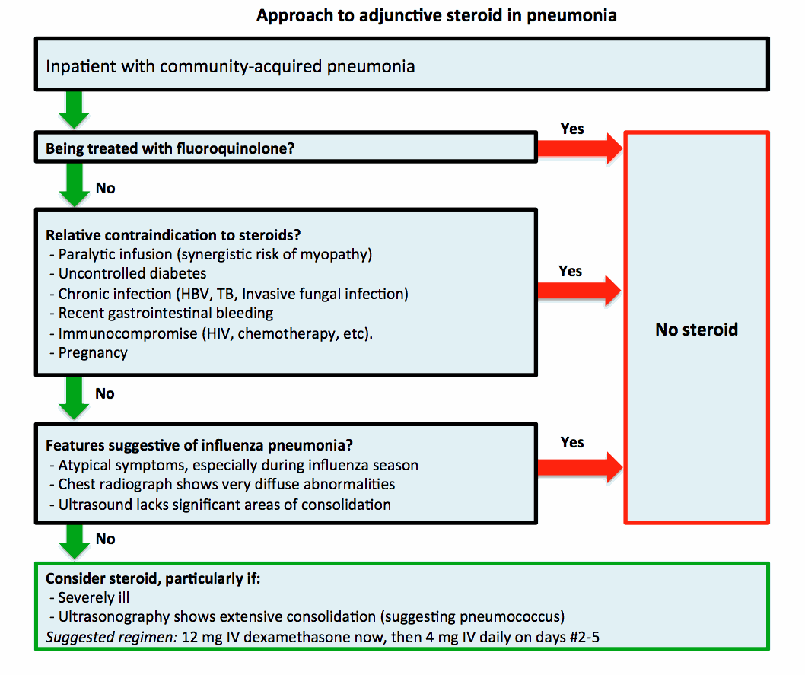](https://i2.wp.com/2.bp.blogspot.com/-Jf6AJwHckdI/VdFA1yo7IdI/AAAAAAAABtg/rO1Z2gfuz3c/s1600/steroidalgo.gif)

.

In the absence of comparative data, a variety of steroid regimens are reasonable.  Dexamethasone has two advantages compared to other agents.  First, it has little mineralocorticoid activity, causing less volume retention.  Second, it has a long biological half-life (~2 days), so it will gradually auto-taper following discontinuation.  One reasonable regimen would be 12 mg IV dexamethasone immediately, followed by 4 mg/day IV on days #2-5 for a five-day course (3).

.

**Conclusions**

.

At the most basic level, treating infectious disease is about killing bacteria.  For CAP, this isn't difficult.  It is possible to generate many suitable antibiotic regimens (e.g. levofloxacin, moxifloxacin, ceftriaxone plus azithromycin, ampicillin-sulbactam plus azithromycin, doxycycline plus ceftriaxone, etc.).

.

It's more complicated though.  Antibiotics modulate the amount of inflammation that occurs as bacteria are killed (e.g. ceftriaxone causes release of pneumolysin, whereas azithromycin inhibits it).  Azithromycin and fluoroquinolones directly suppress inflammation.  Steroid may be helpful in suppressing inflammation incited by ceftriaxone, but perhaps unnecessary when combined with moxifloxacin.  Understanding this *ménage a trois* between bacteria, antibiotics, and the immune system may help us optimize therapy.  Killing bacteria is easy, but saving patients is tricky.

.

Recent RCTs and meta-analysis support the use of steroid in CAP.  This is consistent with a benefit of steroid in meningitis, cellulitis, pharyngitis, and septic shock (4).  Bactericidal antibiotics may trigger the release of inflammatory bacterial products as bacteria are lysed, so an antibiotic-steroid combination could be ideal to allow bacteriolysis without excessive inflammation.

.

Overall, for severe CAP available evidence supports a combination of beta-lactam (e.g., ceftriaxone or ampicillin-sulbactam) plus azithromycin, with steroid unless contraindicated.  Important questions remain, including exactly which patients may benefit from steroid and how to use fluoroquinolones.  We're only beginning to scratch the surface of this ancient disease.

.

[](https://i0.wp.com/2.bp.blogspot.com/-honPzz54ZPM/VOp9rDi3i6I/AAAAAAAAA8Y/Ci5FGLLAqjI/s1600/bullet.gif)

* Treatment of pneumococcus with ceftriaxone increases inflammation, whereas azithromycin and fluoroquinolones have some anti-inflammatory properties.
* For patients without risk factors for MRSA or pseudomonas, the best antibiotic selection may be the combination of azithromycin plus a reasonably broad-spectrum beta-lactam (e.g. ceftriaxone or ampicillin-sulbactam).
* Multiple large RCTs have demonstrated benefit of adjunctive steroid.  The most robust finding is reduced hospital length of stay, with additional evidence that steroid reduces the need for intubation.
* For patients with severe CAP who look like they might deteriorate and require intubation, a maximally aggressive approach may consist of immediate *quadruple therapy* with ceftriaxone, azithromycin, steroid, and [high-flow nasal cannula oxygen](http://emcrit.org/high-flow-nasal-cannula/pneumonia-bipap-secretions-and-hfnc-new-lessons-from-florali/).

[](https://i2.wp.com/1.bp.blogspot.com/-Jf6AJwHckdI/VdFA1yo7IdI/AAAAAAAABtk/6t39bZWQwoY/s1600/steroidalgo.gif)

**Related posts**

* [Radiographic and ultrasonographic patterns of CAP](http://emcrit.org/bronchopneumonia/proposal-most-community-acquired-pneumonias-with-extensive-ultrasonographic-consolidation-are-pneumococcus/).
* [Myth-busting: Azithromycin does not cause torsade de pointes or increase mortality](http://emcrit.org/torsade-de-pointes/myth-busting-azithromycin-does-not-cause-torsade-de-pointes-or-increase-mortality/).
* Treating infection is about more than killing bacteria:  [Management of toxic shock syndrome](http://emcrit.org/clindamycin/toxic-shock-syndrome-management-a-tale-of-two-patients/).
* Understanding steroid in critical illness:  [Stress dose steroid in sepsis](http://emcrit.org/steroid/steroids-in-septic-shock-four-misconceptions-and-one-truth/).
* [High-flow nasal cannula for pneumonia (FLORALI study)](http://emcrit.org/high-flow-nasal-cannula/pneumonia-bipap-secretions-and-hfnc-new-lessons-from-florali/).
* Debunking [double coverage of pseudomonas with a fluoroquinolone](http://emcrit.org/levofloxacin/double-coverage-of-gram-negatives-with-a-fluoroquinolone/).